Power Ethiopia

Business plan

*Prepared by:*

*Dr. Greg Beaucage*

*Professor of Chemical*

*and Materials Engineering*

*University of Cincinnati*

*Cincinnati, Ohio 45221, USA*

*Mr. Berhanu Mengistu*

*Lecturer of Physics*

*Haramaya University*

*Department of Physics*

*Haramaya, Ethiopia*

*Dr. Fekadu Lemessa*

*Academic Vice President*

*Dire Dawa University*

*Dire Dawa, Ethiopia*

**1. Executive Summary**

Photovoltaic solar panels have limited distribution and use in Ethiopia due to high import tariffs, lack of widespread financing arrangements, mismatch between PV-panel design and Ethiopian architectural design, the failure of available devices to target the essential needs and financial capabilities of rural and urban Ethiopians, and the absence of a local technical support network and coordinated sales team to maintain installed PV devices and expand the PV market to Ethiopian consumers. These issues can be addressed by a university-based spinoff corporation, *Power Ethiopia*, that leverages technical expertise, facilities and administrative guidance at Haramaya and Dire Dawa University. In collaboration with the Universities, *Power Ethiopia* can train a cadre of technical, design and marketing experts who will find employment in the growing sustainable energy market they will help develop in Ethiopia.

*Power Ethiopia* has three goals: 1) Manufacture of PV panels targeting the rural and urban Ethiopian consumers at an affordable price with viable financing arrangements. 2) Training of a new generation of entrepreneurial technologists and businessmen who will expand the market for PV’s in Ethiopia as well as support indigenously manufactured and locally installed equipment. 3) Enhance the economic situation for faculty and administrators at Ethiopian universities through an Ethiopian adaptation of the US university-based startup incubator model.

The neighboring sites of Haramaya University and Dire Dawa University provide uniquely suitable environments for the indigenous assembly of Ethiopian PV panels. They are located approximately at the midpoint between the Red Sea port of Djibouti and the population center of Addis Ababa, Figure 1. Dire Dawa is a manufacturing center having been founded to support the construction of the Ethio-Djibouti Railway at the turn of the century. Dire Dawa is the second largest city in Ethiopia. The university settings offer secure locations with reliable grid electricity and water supply. The rail and highway link to Djibouti on the Red Sea offers direct access to PV components from Asia through the Arabian Sea and Europe/North America through the Suez Canal.

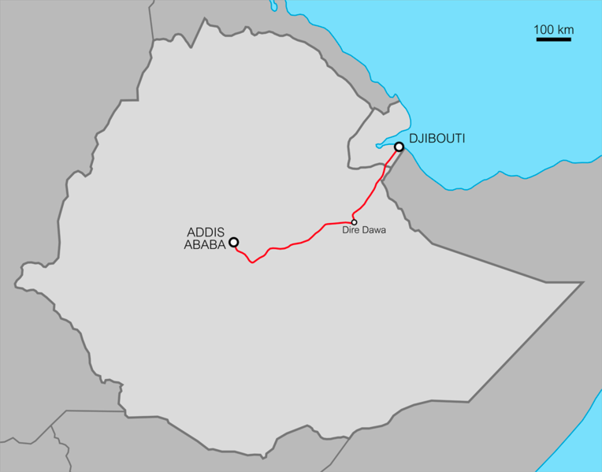 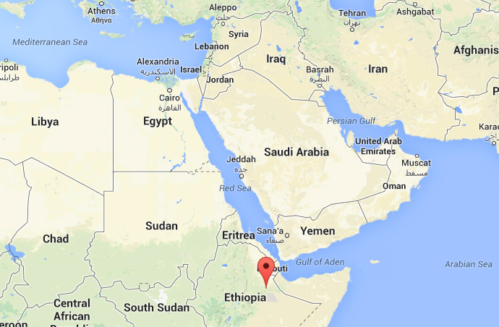

a) b)

*Figure 1. a) Dire Dawa and Haramaya are located at the midpoint between the port of Djibouti and the population center of Addis Ababa. Dire Dawa is the second largest population center in Ethiopia. The region has some of the highest solar irradiance on earth with a population of 95 million and 90 million in a rural setting 70 million far from grid power. b) The two sites offer accessibility to the Ethiopian market of 95 million people and to the port of Djibouti on the Red Sea with shipping connections to Asia and the Mediterranean Sea through the Suez Canal.*

Figure 2b shows the proposed sit of the PV assembly plant at the new Technical Institute on the Haramaya University Campus. HU has committed to provide space for the initial assembly facility that will require an open working space of about 185 m2 (2000 ft2) with 220 V power and water. The assembly area will need some specially designed worktables and other infrastructure that will be initially provided by the shop at HU and the HU facilities office. HU has also committed to providing some financial startup resources for the effort. In addition to support from the universities, the PE management team is organizing startup funding from investors in Cincinnati, private investors in Addis Ababa, funding from USAID and the US Embassy in Addis, the Ministry of Water & Energy, the Ministry of Education, and several non-governmental organizations (NGOs) such as Concordia Humana and Solar Light for Africa as well as private companies such as Sharp Electronics.

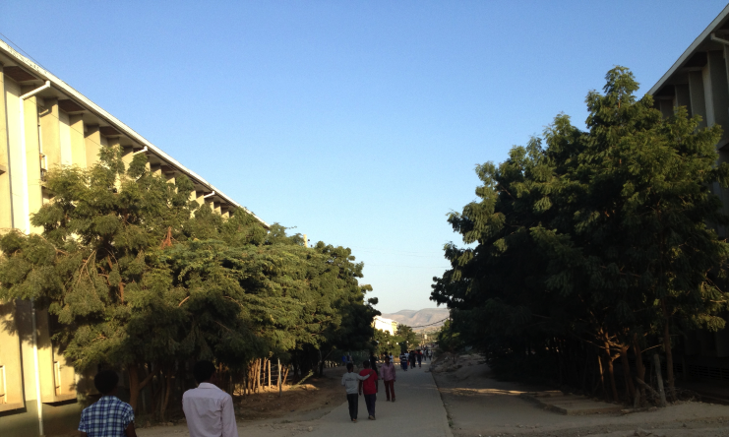 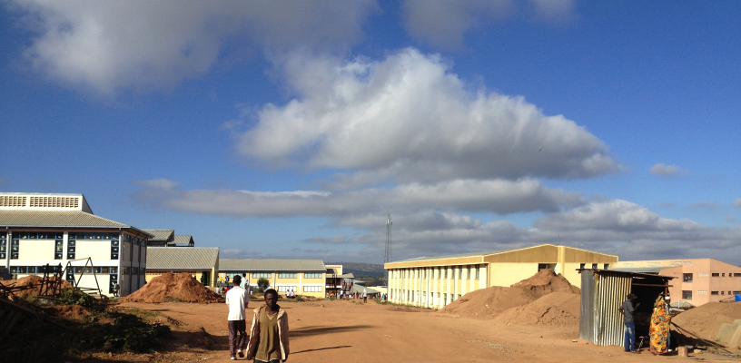

a) b)

*Figure 2 a) Campus of Dire Dawa University. b) Proposed site for PV assembly plant at the new Institute of Technology on the Haramaya University campus.*

PE will, to some extent, rely on contacts local to the University of Cincinnati to attract some foreign private investment and to develop initial contracts for the supply of component parts necessary for the assembly of PV panels. Deborah Schultz CEO of *Transborders Solutions®* in Cincinnati has been instrumental in organizing most of these logistical supports for PE. For example, Sharp Electronics is in negotiation to supply wafers and some other components for the PV assembly. There are also several investors interested in supporting this project from the initial stages.

The initial market for Ethiopian PV panels in the first few years of Power Ethiopia (PE) operation will be the two participating universities, the city of Dire Dawa, and small-scale foreign aid projects in the Hararghe/Oromo regions targeting rural development such as the Haraghe Catholic Secretariate and projects funded by activities of the University of Cincinnati in these areas. In these two years assembly of conventional 150Wp panels will be brought to large enough production capacity so that large-scale orders can be processed. The Ethiopian Ministry of Water & Energy has informally committed to purchase on the order of 1M such panels over a three-year period for installation in rural communities across Ethiopia if capacity and quality can be demonstrated. Supply to these larger-scale government funded activities will support intermediate-term goals of return on the initial investment.

Longer-term strategies involve working with non-government organizations targeting the marketing and support of PV technology in Ethiopia, particularly, the Solar Energy Foundation (Stiftung Solarenergie) which operates for the most part in northern Ethiopia, and parallel efforts in southern Ethiopia, where HU and DDU are located, that will be initiated at the two partner universities in collaboration with the University of Cincinnati, the Cincinnati Rotary Club and the Bole-Addis Rotary Club. Efforts will be made to design PV systems compatible with rural and urban endemic architecture and lifestyles taking advantage of world leading design expertise at the University of Cincinnati’s School of Design and Architecture (DAAP) and faculty with experience at architectural design in east Africa coupled with technical and cultural expertise at HU and DDU.

In the long term PE also plans to develop assembly of deep-cycle batteries for use in off-grid solar and wind power applications. Similar to PV assembly, the assembly of conventional deep-cycle batteries is essentially a low-technology labor-intensive manufacturing process adaptable to the conditions that exist at the HU and DDU sites with similarities in the need for supply lines to Asia and Europe for component parts.

Intellectual property (IP) rights in Ethiopia are weakly enforced. Ethiopia is signatory to a number of international IP treaties especially focusing on trademarks, seeds/biological materials and pharmaceuticals and an Ethiopian Intellectual Property Office exists in Addis. Implementation of IP protection is extremely rare in Ethiopia and, for the most part, there is little international interest in restricting manufacturing for domestic consumption in sub-Saharan Africa with the exception of South Africa. This situation is useful for the nascent effort at PV assembly where the initial stages of growth will be effectively unhindered by international IP protections. In the long term, the lack of IP protection could be detrimental to research and development efforts. Since PE is focusing on the indigenous market with products targeted to the Ethiopian climate, architecture, and culture, the IP environment in Ethiopia is beneficial to the PE business plan.

US Embassy states: “*Regulations for the registration of patents and trademarks do not exist in Ethiopia. Some protections can be secured through registration of patents and trademarks with the Ministry of Trade and Industry and the publication of cautionary notices in local newspapers in Ethiopia. Two copies of the newspaper notices should be sent to the Ministry of Trade and Industry.*” (http://ethiopia.usembassy.gov/doing_business_in_ethiopia.html)

In addition to the economic benefits of PE, the effort will advance higher education in Ethiopia by introducing cooperative educational experiences for students and faculty at HU and DDU. The cooperative education model is important to this business plan since it will provide a well-trained workforce composed of the future leaders of the Ethiopian off-grid power and technology sectors. Engineering, science, design and business students at DDU and HU will be able to apply what they have learned in course work to the development of a new manufacturing effort. The University of Cincinnati is a leader in cooperative education having the first mandatory coop program in the US. This approach was modeled after the German university technical education system. These students will be encouraged to work in the PV sector after graduation through training at the universities and through their exposure to these devices and the business model that will be developed in the PE effort. Faculty at DDU and HU will also participate in the management of the assembly plant and will be able to enhance their salary through work at the assembly plant during their recess periods. A certain number of faculty and students will choose to transfer full time to the PE project. The universities will also benefit financially from expansion of PE on their campuses through a financial return on their investment of facilities and direct financial support. PE will be the first example of university spinoff/cooperative education in Africa and could serve as a model for university based economic development in sub-Saharan Africa.

Power Ethiopia is a promising effort to couple existing resources in the academic sector with development needs for clean, off-grid power. PE can also provide spinoff benefits to the Universities in terms of income, training, and integration with the Ethiopian business community. DDU and HU are strategically located to take advantage of the port of Djibouti and the market of Addis Ababa as well as the broadly dispersed population of the Haraghe and Oromo regions of Ethiopia. Newly modernized rail and interstate grade highway connections between Djibouti, Dire Dawa and Addis Ababa will spur future growth of PE markets across Ethiopia from this geographic base in the Hararghe region.

***Time-line for Power Ethiopia.***

1. **Purpose of the plan**

The purpose of this business plan is to explore the potential for solar panel assembly on Haramaya and Dire Dawa University campuses coupling education, training, marketing, manufacturing and business development that target the Ethiopian rural and urban markets for renewable energy.

1. **Product or service and its advantages**

The products for this business are indigenously manufactured photovoltaic solar panels designed for use in rural and or urban settings in Ethiopia. For example, a polycrystalline panel that can be attached to a tin roof with a capacity of 150Wp to power four LED lights, a radio and a cell phone charging station packaged with a battery and charge controller. For urban/village settings an example is the use of solar power for streetlights funded by international donations involving a small solar panel, charge controller and battery coupled to an LED street lamp. It is expected that a number of target products will be developed over time.

1. **Market opportunity**

The potential market for off-grid power in Ethiopia is enormous. Ethiopia is a country of 95 million people with population expected to reach 160 million by 2060. Of the current 95 million people approximately 90 million live in a rural setting with limited potential to ever have access to grid power. Even in urban Ethiopia grid power is unreliable. Frequent blackouts lead to a large market for security and street lighting based on off-grid sources. Solar power lighting can meet this need and also provide a new level of security and safety to rural villages where the only light at night typically comes from fires made with brush firewood. According to the UN the average per capita income in Ethiopia is about $410 (2012). A typical wage is $2 per day for a day laborer (40 ETB). The current cost for photovoltaic panels and any technological device is roughly 2.5 times the typical cost in the US or in Europe mostly due to import duties, shipping and the lack of access to web-based international marketing due to the almost complete absence of credit cards or other payment methods in SSA. For these reasons PV panels are almost completely absent from Ethiopia, with the exception of cell phone towers, despite Ethiopia being one of the most opportune locations for the use of photovoltaics with the highest solar irradiance on earth, location near the equator with 12 hours of sunlight throughout the year, moderate temperatures and a highly dispersed population that does not have any real potential for grid electrification, and a highly unreliable grid power system where it is available.

Several groups have found the potential for a large market for PVs in Ethiopia such as Stiftung Solarenergie from Germany, which is an organization with operations in the north of Ethiopia that develops rural technicians to market and support chiefly Chinese polycrystalline photovoltaics for small scale lighting and to power some electronics such as cell phone charging and radios. SS has had significant success in bringing PVs to rural Ethiopia through an innovative marketing mechanism involving time payment and a team of local franchised experts in business to support the expansion of solar energy. A similar model is used in Uganda by *Solar Energy for Africa* as well as by other groups in SSA. A key element for a sustainable market among the rural poor is financing through time payments collected by local technical experts. Organization of these franchised business units is a key element in the delivery of solar energy to rural Ethiopia in the long term. SS has shown this business model to be viable in Ethiopia even when the equipment costs are 2.5 times that in the developed world.

In the short term there exist several large niche markets that can support the development of including federal and local government purchases, NGO purchases, and support of the telecommunications industry. In many cases there is a strong political will to purchase indigenously manufactured PVs. In all cases it is possible to under sell imported PVs by price while offering a higher quality product designed for the Ethiopian market with local technical support.

Currently a consultative meeting has been conducted with the Ministry of Water & Energy on the market opportunity of the products and there is full confidence to sell the products to individual customers and governmental and nongovernmental organizations. The Ministry of Water & Energy has plans to purchase and install 2M PV panels in the next few years, a purchase that could support the initial stages of business development. Additionally, the universities themselves will provide a test market for the initial production of PV panels. The city of Dire Dawa is already installing Chinese solar panels to light streets and we have a working relationship with an NGO in Dire Dawa that specializes in solar powered water systems for rural villages.

The current situation is excellent for both short-term markets for PV panels in the Hararghe/Oromo regions as well as for expansion to a national market when manufacturing capabilities permit. The university sites offer a unique incubator for the growth of *Power Ethiopia*.

The initial small-scale, startup market in the first year of operation involving University sales, sales to local communities and NGOs is estimated at 100 PV panels per month. This level of production will allow for the development of a high standard of quality control over the first two years of production. A 150W peak, polycrystalline panel will sell for approximately $500 in Addis Ababa or Dire Dawa. Components for this panel can be imported in Ethiopia for about $340 on a small scale with approximately 8 hours labor to assemble a panel mostly involving soldering of PV chips and checking connections as indicated in Table 1. Table 1

*Table 1. Estimate of the Expenses Involved in Assembly of 50 150 Watt Peak Power Polycrystalline Solar Panels at HU/DDU (bracket values are estimate costs for moderate-scale production ).*

|  |  |  |  |
| --- | --- | --- | --- |
| **Component** | **Approximate Unit Price with Delivery to Dire Dawa, Ethiopia, USD** | **Number of Items for one 150 W Peak Panel** | **Approximate Price per Panel for a lot of 50 Panels, USD** |
| Polycrystalline Solar Cell (1.7 Wp; 3.5 Amax; 0.5 V) | 2.00 (1.20) | 90 | 180 (108) |
| Tabing Wire and Bus Wire | 20 | 1/2 | 10 |
| Flux Pen | 1 | 1 | 1 |
| Solder | 1 | 1 | 1 |
| Testing Diodes | 0.25 | 4 | 1 |
| 65 Watt Soldering Iron | 50 | 1/50 | 1 |
| Aluminum Frame | 15 (5) | 1 | 15 (5) |
| Archival Glass | 40 | 1 | 40 (30) |
| Encapsulating Resin (Silicon) | 90 | 1 | 90 (35) |
| Assembly Labor | 4 | 1 | 4 |
| Management | 5 | 1 | 5 |
|  |  |  |  |
| Total Costs |  |  | 348 (200) |
| Profit |  | 50% | 174 |
| Shipping |  |  | 20 |
| Selling Price |  |  | 542 |

indicates a worst-case scenario for a small-scale purchase of solar panels. Even with this pricing it is possible to make 50% profit and match the existing market price for similar panels that are generally of lower quality compared to what could be produced at HU/DDU. For moderate-scale production (400 panels per month) cost estimates are given in brackets in Table 1. With expansion of production many of the costs in Table 1 will be reduced.

1. **Management team**

*Power Ethiopia* will be managed by a Board of Directors that will meet biannually to discuss operations and major management decisions, Figure 3. Daily management decisions will be conducted by a Chief Executive Officer, Bernhan Mengistu and by an Operational Manager at Haramaya University and Operational Manager at Dire Dawa University. The operational mangers will be in charge of the staff at the two facilities. Initially operations will be focused at the Institute of Technology at Haramaya University. Both Dire Dawa and Haramaya students and faculty will participate in the work at the Technology Center with housing for Dire Dawa students provided at HU. *Power Ethiopia* will also have an Advisory Board composed of several stakeholders with vested interests in the success of the corporation. The Advisory Board and Board of Directors will have Chairs who will be responsible for organization of meetings of the boards.

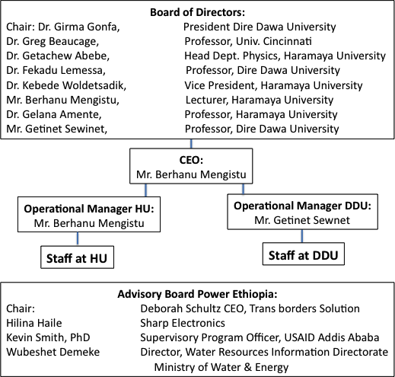

Figure 3. Management structure for *Power Ethiopia*.

**2. Company Description**

1. **Promoters**

The promoters for this business are Haramaya University, Department of Physics, Dire Dawa University, Ethiopia and the University of Cincinnati, Cincinnati, Ohio, USA.

1. **Management structure and areas of responsibility**

Figure 3 shows the management structure for *Power Ethiopia*. The company will be managed in the long term by a board of directors who meet bianually. Daily operations will be overseen by a CEO, Berhanu Mengistu. The HU and DDU sites will have Operational Managers who are listed in Figure 3 who will be in charge of the assembly operations. Each site will have a staff associated with production including cooperative students and part time or full time faculty from the universities.

The project will have an Advisory Board who will guide the company in business decisions. A tenetive Advisory Board is listed in Figure 3.

1. **Shareholders names, no. of shares, % shareholding and cash investment to date**

Power Ethiopia has not yet been incorporated so there are no current shareholders. The current financing involves a verbal commitment from Haramaya University to provide facilities for the initial assembly plant and to continue to support the company through its lifetime as a partnership that supports their educational mission. A similar verbal agreement has been made with the President and administrative staff of Dire Dawa University. Informal discussions for support from a number of investors in Cincinnati and in Addis Ababa have been initiated by the board of directors.

**Advisors**

Power Ethiopia has had a number of informal discussions with financial and legal contacts in Cincinnati and in Addis Ababa. We are currently in the process of assembling a team of legal and financial advisors to support the company. Deborah Schultz of Transborders Solutions is central to this in Cincinnati and Gemechu Desta in Addis Ababa.

Deborah E. Schultz, President

TRANS-BORDERS SOLUTIONS

3500 Holly Avenue, Cincinnati, OH 45208

O.513-321-1415  C. 513-374-8219

[info@transborderssolutions.com](mailto:info@transborderssolutions.com)

TransbordersSolutions.com

Gemechu Desta

Project Coordinator

Tracking Trends in Ethiopia´s Civil Society Sector (TECS) - DFID Ethiopia

Tel.: 00251-912-000006 (cell)

Bole Dabi Complex, 6th Floor

Addis Ababa, Ethiopia

**Products and services**

**Background to its development**

Since the year 2010 Haramaya University has been partnering with Cincinnati University through the USAID project *NanoPower Africa* to advance research and technology transfer in photovoltaics in addition to student and faculty exchange. This cooperation has taken another dimension when the students from the University of Cincinnati and Haramaya purchased and installed solar panels in a village near Haramaya University funded by the Cincinnati Rotary Club and by the Addis/Bole Rotary Club. Due to the fact that importing these panels takes time (9 month order/deliver cycle) and also is too expensive, it was suggested to assemble solar panels locally so that it would be possible to reduce the cost by more than half owing to low labour costs in Ethiopia and no import duties on imported components.

**Benefits and Features**

1. The implementation of solar energy means a fundamental improvement in a day-to-day life for the people in rural areas.
2. Solar energy will enable the application possibilities of light, (in roads & rooms), medicine refrigeration, solar computers, water pumps & water disinfection in the rural areas.
3. *Power Ethiopia* creates job for technicians involved in installing, maintaining and servicing the system. This may lead to the establishment of micro-technicians who can do the work in organized manner.
4. *Power Ethiopia* will provide opportunity for faculty and students at HU and DDU to put their skills and knowledge to work for the development of Ethiopia, creation of jobs and improvement of living conditions. Students will gain real world experience through a cooperative education model. PE will gain a highly skilled work force and a stable environment for corporate growth.

**Unique selling points**

Power Ethiopia has several advantages over competetive proposals for photovoltaic assembly plants in sub-Saharan Africa.

-Commitment of a stable, technically savy environment at Haramaya Univeristy and Dire Dawa University.

-Market protection provided by extremely high import duties on manufactured solar panels and the lack of any import duty on assembly components.

-Initial market provided by the universities and city of Dire Dawa as well as early stage market provided by the Ministry of Water and Energy.

-Expansion of transportation through a nearly built interstate-style highway and modern rail link from Djibouti to Addis Ababa through Dire Dawa that expands the potential market to the entire population of 95 million Ethiopians.

-The location of DDU and HU on the newly renovated transportation paths and the link to the port of Djibouti as well as local demand in the Hararghe/Oromoian regions and the strong local work force provided by the universities and the city of Dire Dawa make this location and the involvment of the universities ideal for a solar panel assembly plant.

*Power Ethiopia* is the first attempt to assemble solar panels in Ethiopia. At HU and at DDU there is active research towards material synthesis, characterization and development. Both universities have programs targeting photovoltaics manufacturing. Currently there are a huge number of graduates of TVET (Technical Vocational Education and Training) at HU who can be involve in *Power Ethiopia* providing relatively inexpensive and trained labour. 95 million Ethipians provide an enormous national market for photovoltaics that *Power Ethiopia* can address.

*Power Ethiopia* has the strong suppor of the Ethiopian Ministry of Water and Energy. The ministry appreciates the idea of establishing a solar panel assembly plant in Ethiopia since there is a growing market for PVs. The Ministry is verbally committed to directing funds for rural electrification to purchase locally available solar panel systems manufactured by PE.

**Advantages to customers**

The rural community, in Ethiopia, uses kerosene for lighting while fire woods and excrement of animals for cooking. Thus with the introduction of alternative energy sources like solar, it will have the following advantages

1. Improve the health status of the community
2. Prolonged the study time of children of rural community therefore their academic performance can get improved.
3. Reduce carbon emission
4. It serves as a means of income by contracting the system for lighting, cooking, TV & printer operation and mobile charging etc to the rural community.
5. Rural Schools lighting, powering computers and accessories and pump water from well.
6. *Power Ethiopia* will provide higher quality PVs compared to imported Chinese solar panels.
7. PE will provide solar panels at a lower cost compared to imported solar panels that are subject to a large import duty and transportation costs.
8. PE will provide solare panels supported by local technical experts and a local assembly plant that can support trained service technicians.
9. PE will design new solar panels that are accommodated to the local Ethiopian architecture and customs. PE solar panels are designed by Ethiopians for the Ethiopoian market.
10. PE will develop time payment and microfinance schemes to grow PV markets in the rural and urban settings.
11. PE will work closely with the Ethiopian government and with NGOs to provide PVs for targeted development markets.
12. PE will enhance the education of students at HU and DDU. These students will provide locally trained technical expertise to the Ethipian PV consumers.
13. PE will provide added income and training to faculty at HU and DDU. These faculty will in turn target some of their research efforts towards improved PVs for Ethiopia.
14. PE solar cells will be one of the first technical devices manufactured in Ethiopia. This involves a significant national achievement and enhancement of Ethiopia’s national pride.

**Disadvantages or weak points**

*Power Ethiopia* will rely on imported solar cells and encapsulation polymers which add a significant component to cost of the assembled solar panel. The growth of assembly plants in Ethiopia and a long term growth of an export market may create sufficient demand to invest in a solar cell chip manufacturing plant at some point in the future. The advantage of using imported chips is that as technology changes PE can quickly adapt and substitute lower cost and higher efficiency technologies. Many of the future technologies for PVs such as polymer based PVs and dye sensitized systems could be easily manufactured in Ethiopia. As these technologies advance, PE will be in a good position to take advantage and impliment these new, low cost technologies.

*Power Ethiopia* is still in the nascent stages of growth. It is required to assemble a team of business, legal and technical experts for the dream of an Ethiopian PV assembly plant at HU and DDU to come to fruition. Progress towards this goal is well underway.

**Future developments**

**Long Term Aim of the Business**

Some years African Universities team up with University of Cincinnati to promote basic research and development in material sciences. A twenty years plan has three components which includes

1. Material synthesis, characterization and fabrication which can be used for solar energy conversion, agriculture and west treatment.
2. Commercialization of the newly developed materials for to generate income.
3. Up until the time the local materials are developed, there is a plan to establish a plant which can construct solar panel locally.

This business plane stem from the third component of the twenty years strategic plan designed amongst the major actors of the project.

**Objectives**

This company is not meant to make huge profit. The overall objective is to provide solar panel systems to the rural community and beyond at the affordable expenses. It is also aiming at job creation to the unemployed youth at the vicinity of the focal University. In the next five years

1. Mobilizing signing MOU with potential stakeholders (Ministry of water and energy, development partners Universities, PV wafer produced ) to lay solar panel plant infrastructure
2. Recruit and train permanent and provisional employees of the plant to their full capacity, besides recruit and organize TVET graduates who do the work of installation, maintenance and service at the household level.
3. Currently, all the solar panels installed are imported from abroad mainly from India and China.

**SWOT Analysis**

|  |  |
| --- | --- |
| **Strengths**   * Well established solar panel installation and operation in the rural area of the region * There is a working research lab for promotion of PV cell in terms of efficiency with 20 years plan towards the development of solar cells from locally available materials. * Availability of Trained human power with technical expertise. * Haramaya University management has a strong commitment and initiation to the implementation of the project. Workshop has been built for the plant ahead of time. | **Weaknesses**   * Poor transportation system to the rural areas where the solar cell products are being mobilized. * There is no any Solar panel production plant locally from which you get start up experiences. |
| **Opportunities**   * Promising and conducive market in the rural area of the region * There is easy access and proximity for the solar assembly to be imported from the port * Availability of similar solar cell trade companies except the manufacturing stages in the north and south of Ethiopia * Failure of battery systems of some existing solar electrification companies in the country. * Promise from federal government officials that if the panel plant production is operational locally; the fund obtained for rural electrification would be redirected to purchase locally available solar panel system. * Conducive government energy policy. * Provision of Temporary Taxes relief by the government to import inputs to the solar panel production plant | **Threats**   * Delay at maritime transit and shortage of foreign currencies. * Lack of basic knowledge and trust of the customers in purchasing the product manufactured locally. |

**3. Market Analysis**

**Target Market**

This solar panel manufacturing plant is meant for a profit which can sustain the plant by its own. It is basically a centre for training science and engineering university student education and also serves as youth employment beginning from production to distribution, installation and maintenance.

However, the main market of our solar products primarily will be the farmers in the rural area of Eastern and Western Hararghe zones of Oromia Regions.

This is based on the information which was obtained from the office of Rural Electricity Development and Promotion Agency based in Addis Ababa. This governmental agency has the mandate to develop new energy sources and also do promotion works to the already available technology in the world to the rural community and to the whole nation at large. In this regard currently as pilot test the ministry plans to install 25,000 solar panels. As it stands now, the agency in collaboration with the governments of Japan, Norway and China, managed to install and make operational about 23,000 solar panels out of the planned 25,000 and transferred to the rural users. Given the huge growing demand, this figure can be projected up to 150,000 panels by the end of GTP (Growth and Transformation Plan) year 2015. However, it will even be by far more than the anticipated to be 1,000,000 solar panels as and beyond the second phase of GTP.

Moreover, the solar power trade company in the northern and southern part of Ethiopia will also be potential customers of our products in the market.

Thus the ministry appreciates the idea of establishing solar panel plant here in Ethiopia explaining the fact that there is a growing market for such systems. He even went on saying if the panel plant is operational; the fund obtained for rural electrification would be redirected to purchase locally available solar panel systems.

**Competitive Advantage**

Currently, there is no single company, in Ethiopia, manufacturing the solar panels locally. Therefore, there will be an ample opportunity of creating solar trade market in the country if there is a possibility of establishing solar products manufacturing company locally. As it goes now, it was learnt from the ministry, the task of rural electrification is supported by various development partners like World Bank, African Development Bank, Mashe, and Light Africa etc. Besides German own nongovernmental organization and local private companies are also taking part to support the efforts. These organizations provide financial support to the ministry. The ministry, after raising the fund, signed memorandum of understanding with a NGOs and private companies so that they can import the solar power systems (the panel, battery and accessories) from abroad mainly from India and China and sell to the user at the subsidized cost of 280 – 800 birr per system.

However after the systems were installed and transferred to the users, it was learnt that in some situations there were malfunction of the systems due to battery failure. To secure consumers’ confidence on the product, they are now being replaced by genuine batteries. The level of acceptance of the solar panel system by the rural community is promising as testified by the growing demand of the systems.

**Profile of Competitors**

There is no single competitor from the panel production point of view. Though there are NGOs and private companies working in the trade of the solar panel system, the cost is unbearable by the majority rural customers since they are importing from abroad. In our case the system will be assembled and manufactured locally where there is a relatively cheaper labour cost that will make the product affordable by the customers.

**Benefits to Clients**

1. Improve the health status of the community
2. Prolonged the study time of children’s of rural community therefore their academic performance gets improved.
3. Reduce carbon emission and save money that could otherwise be spent for kerosene.
4. Has a great impact of facilitating their work since it is an energy source that is always harnessed from nature.
5. Serves as means of income by contracting the system for mobile charging etc.
6. Creates job for technicians involved in installing, maintaining and servicing the system. This may lead to the establishment of micro-technicians who can do the work in organized and legalized manner.
7. The solar products manufactured locally are definitely sold with reasonable price that takes the economic situation of the customers. Hence this gives an opportunity to reduce their energy expense in the market which in turn has a positive impact in saving their extra money they may spent for energy consumption.
8. Ethiopia being located around the equatorial region has a positional advantage that makes it to receive direct sun light throughout the year. This in turn guarantee sustained solar energy for house hold consumption and hence they don’t have to go to the market to purchase kerosene lamp and collect fire woods thereby it saves their time in fetching the energy source from the market.

**4. Marketing/Sales Strategy**

**Marketing Strategy**

The main targets of the market will be primarily the rural area where high demand of alternative energy source like solar products is required. Moreover, existing solar product trade companies will also be the prime targets of our market because there is a failure of some components of the solar panel system (battery) which can easily be accommodated if solar products are manufactured locally.

In order to differentiate our products specifications on the efficiency of the solar electrification will be labelled and a feedback mechanism after distribution of our products will be established.

There have been more than three rural test sites in the vicinity of the manufacturing site where solar products are installed and tested and there is a promising feedback from the users that it is efficient and valuable for their daily energy consumption.

A number of local trade agents have been established in the potential market areas who can give brainstorming activities to promote market awareness and sales.

The marketing will be carried out by well trained local solar product saleswomen and salesmen who were already acquainted with the psychology of the customers.

Moreover, the ministry has a plan to establish solar panel kiosks in a selected target community to facilitate market linkage, maintenance and other related service that the community may need.

**5. Research and Development**

**To be filled by Dr. Girma**

**Technology Roadmap**

Include

* Team/Department structure
* Methodology
* Platforms used
* Milestones to be achieved
* System Overview Diagram>>

**Research and Development**

**Technical Partners**

**IP, Patents, Copyrights, Brands**

**6. Staffing and Operations**

**Management (including Board) Organisation Chart**

**Staffing**

**Training Plans**

**Operations**

* **Premises**
* **Equipment**
* **Production facilities**
* **Infrastructure**
* **Communications facilities**
* **Costs involved**
* **Suppliers**

**7.Funding Requirements**

Table 2 indicates the funding expenses for the first 7 years of operation. The firs three years are based on 100 150W panels being produced per month (see Table 1). This level of production is increased in 2017 by addition of a facility at DDU and expansion of the rate of production at the existing facilities in 2017 to 2020. Sales based on 542 USD pre 150W panel in 2014. This cost decreases with materials cost reduction as sales increase from 339 USD in 2014; 302 USD in 2015; 266 USD in 2016; 192 USD in 2017 and afterwards.

*Table 2. Funding Requirements (1000s of USD) for Power Ethiopia, five-year plan.*

|  |  |  |  |  |  |  |  |  |
| --- | --- | --- | --- | --- | --- | --- | --- | --- |
| **Expense** | **2014 (3/14 to 12/14)** | **2015** | **2016** | **2017** | **2018** | **2019** | **2020** | **Total** |
| Facilities | 10 | 12 | 12 | 24 | 24 | 24 | 24 | 130 |
| Utilities | 2 | 2.4 | 2.4 | 4.8 | 4.8 | 4.8 | 4.8 | 26 |
| Operating Expenses: | 2 | 2.4 | 2.4 | 4.8 | 4.8 | 4.8 | 4.8 | 26 |
| Materials for Manufacture | 339 | 362.4 | 319.2 | 460.8 | 506 | 557 | 613 | 3157.4 |
| Transportation | 1 | 1.2 | 1.2 | 2.4 | 2.4 | 2.4 | 2.4 | 13 |
| Staff | 4 | 4.8 | 4.8 | 9.6 | 9.6 | 9.6 | 9.6 | 52 |
| Management | 5 | 6 | 6 | 12 | 12 | 12 | 12 | 65 |
| R&D | 5 | 6 | 7 | 7 | 7 | 7 | 6 | 45 |
| Shipping | 20 | 24 | 24 | 48 | 53 | 58 | 62 | 289 |
| Incidental Expenses | 3 | 3 | 3 | 4 | 5 | 5 | 5 | 28 |
| Marketing/ Sales/ Training | 3 | 4 | 4 | 4 | 4 | 4 | 4 | 27 |
|  |  |  |  |  |  |  |  |  |
| Total Costs | 394 | 428.2 | 386 | 581.4 | 632.6 | 688.6 | 747.6 | 3858.4 |
| Facilities/ Trans./ Util. Paid by HU | (13) | (15.6) | (15.6) | (15.6) | (15.6) | (15.6) | (15.6) | (106.6) |
| Facilities/ Trans./ Util. Paid by DDU | - | - | - | (15.6) | (15.6) | (15.6) | (15.6) | (62.4) |
|  |  |  |  |  |  |  |  |  |
| Outstanding Expenses | 381 | 412.6 | 370.4 | 550.2 | 601.4 | 657.4 | 716.4 | 3,689.4 |
|  |  |  |  |  |  |  |  |  |
| Sales | 542 | 650.4 | 650.4 | 1,300.8 | 1,430 | 1,570 | 1,720 | 7863.6 |
|  |  |  |  |  |  |  |  |  |
| Profit+Taxes | 161 | 237.8 | 280 | 750.6 | 828.6 | 912.6 | 1,003.6 | 4,174.2 |
| Est. Taxes 30% of Profit | 37.2 | 54.9 | 64.6 | 173.2 | 191.2 | 210.6 | 231.6 | 963.3 |
| Est. Profit | 123.8 | 182.9 | 215.4 | 577.4 | 637.4 | 702 | 772 | 3,210.9 |
| Income After Taxes | 504.8 | 595.5 | 585.8 | 1,127.6 | 1,238.8 | 1,359.4 | 1,488.4 | 6,900.3 |

The first year outstanding expenses of 381,000 USD will be required prior to operation of the company. This should be paid in full from the first year income with a projected profit in the first year of 123,800 USD. The second year expenses of 389,200 USD are required at the start of the second year. If the first year profits and the original 381,000 investment are applied to the necessary second year advance a return in the first year of . .

Table 2. Cash input necessary for the first eight years of operation.

|  |  |  |  |  |
| --- | --- | --- | --- | --- |
| Year | Expenses | Cash on Hand from Previous Year (Previous Year’s Income After Taxes Plus Excess Cash) | Excess Cash (Cash Needed) | Investment |
| 2014 | 381 | 0 | (381) | 381 |
| 2015 | 412.6 | 504.8 | 92.2 |  |
| 2016 | 370.4 | 687.7 | 317.3 |  |
| 2017 | 550.2 | 903.1 | 352.9 |  |
| 2018 | 601.4 | 1,480.5 | 879.1 |  |
| 2019 | 657.4 | 2,117.9 | 1,460.5 |  |
| 2020 | 716.4 | 2,819.9 | 2,103.5 |  |
| 2021 | 716.4 | 3,591.9 | 2,875.5 |  |

*Table 3. Corporate tax rates in Ethiopia (from the World Bank).*

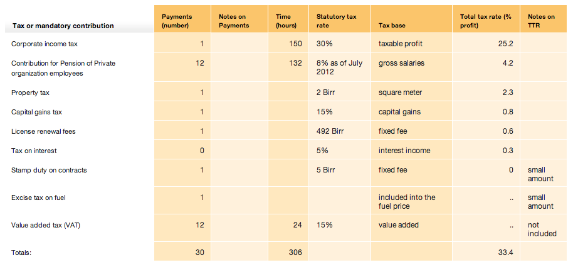

**Sources:**

* **Promoters’ funds**
* **Bank lending**
* **Grants or loans from agencies**
* **Investment already received**
* **Investment sought**

**Required for:**

* **Equipment**
* **R&D**
* **Marketing**
* **Staffing**